CISC7204 Data Science and Data Visualization
Assignment 01 — Preliminary Project Proposal
September 2026

Prepared by: Chen Iat Hong (MC654102) | Tang Chi In (MC660146)
- Project Topic Name: Performance Patterns in the 2025/26 English Premier League
Datasets
- players_data-2025_2026.csv
(link: https://www.kaggle.com/datasets/hubertsidorowicz/football-players-stats-2025-2026)
- Original 2839 players record across the top five European leagues;
(Afterward filtered to 551 Premier-League player stats.)
- Variables: age, position, minutes played, goals, plus goalkeeper-specific metrics.
- season-2526.csv:
(link: https://datahub.io/football/english-premier-league)
- 380 records of all 25/26 Premier League fixtures
- Variables: teams, match result, goals, shots, corners, yellow/red cards.

Abstract
In modern-day football, directors, coaches, analysts, commentators, etc. often rely on and quantify player performance to evaluate the form and trend of the team. Football commentary has become increasingly quantitatively oriented. This project outlines matches, teams and players performance within the 2025/26 English Premier League with a core research question and two supporting questions extending the analysis:

- Primary Research Question
What is the association between offensive & defensive performance of the team and the league points in the 25/26 English Premier League at the end of the season?

- Supporting Research Questions
- Do shots, shots-on-target and corners show consistent differences between home and away games within individual fixtures?
- Is there any relation between outfield player age and goals scored, by considering the playing position and minutes played?

The two datasets form the basis of this analysis: a match-level file covering all 380 league fixtures and a player-level dataset. Since the data only covers one season, all findings are treated as descriptive and no causal claims are made.

- Project Purpose
This project combines actual data science practice with real-world sports statistics and analytics.
- Outcome
Build a Jupyter notebook (Premier League 25-26 Analysis.ipynb) for importing, cleaning, merging and analysing two independent datasets. Generates tables, statistical outputs and visualisations, with explanation revealing relevant information about the performance of the Premier League teams.
- Skills
Practice and study core data science processes including pandas data filtering, data type conversion, duplicate and missing-value validation, cross-dataset name reconciliation, table aggregation and table joining. Develop techniques for correlation analysis, sample comparison with hypothesis testing and explanation about statistical uncertainties.
- Knowledge
Reinforce key differences among player-level, game-level and team-season-level observations; the impact of limited playing time on scoring; the essential difference between statistical correlation and causation. This project also demonstrates the challenges encountered when merging datasets, such as the numerical mismatching issue between goalkeeper and game level statistics.
- Project Tasks
The analysis is completed sequentially in the Jupyter notebook across Section 1-6, with assertion checks for data validation.

- Load and inspect datasets (Notebook Section 1-2)
Import required Python libraries and read the two CSV files. Inspect dataset structures, data types, missing values and duplicates. Perform logical validation such as non-negative shot counts and valid match results. Standardise inconsistent team names to align the two different datasets.

- Team statistics and Data Integration (Notebook Section 3)
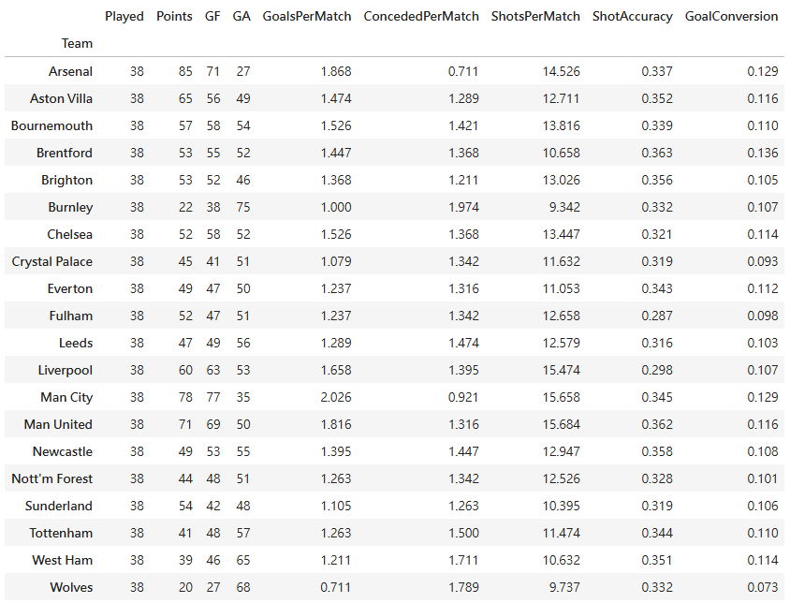
Convert each game result into two records (Home and Away). Aggregate data to team-level to calculate total league points, goals scored and conceded and shot statistics. Afterwards, combine aggregated goalkeeper statistics with team match data, and document numerical mismatches between the two datasets.
- Association between Attack-Defence with League Points (Notebook Section 4)
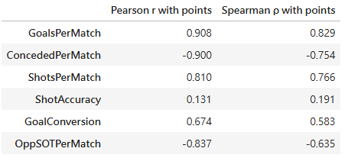
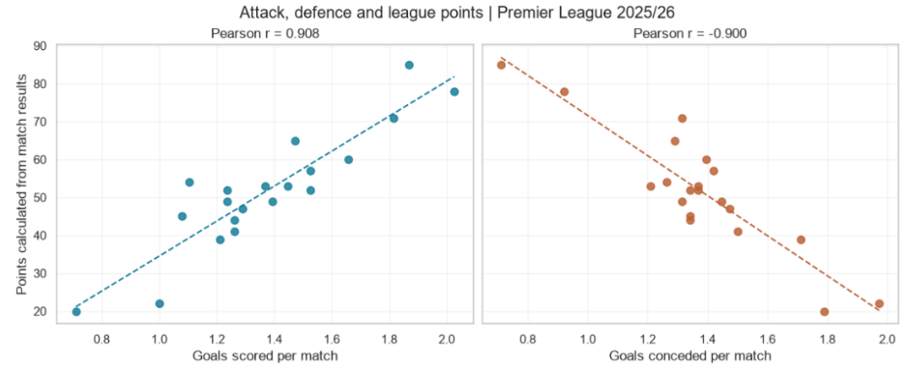
Calculate Pearson and Spearman correlation and generate a dual-panel scatter plot comparing goals per match and goals conceded per match against league points. It depicts how attacking and defensive performance respectively positively and negatively correlated with the total league points.

- Home and Away Performance Comparisons (Notebook Section 5)
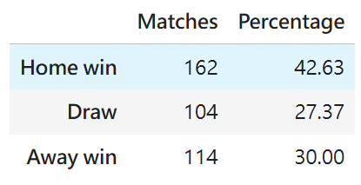
Compute a home-win, draw and away-win frequencies and proportion table, while the grouped bar chart compares the mean values of three attacking metrics between home and away teams.
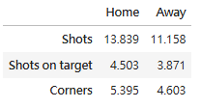
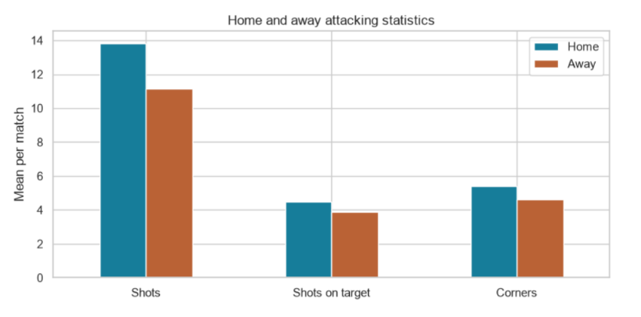

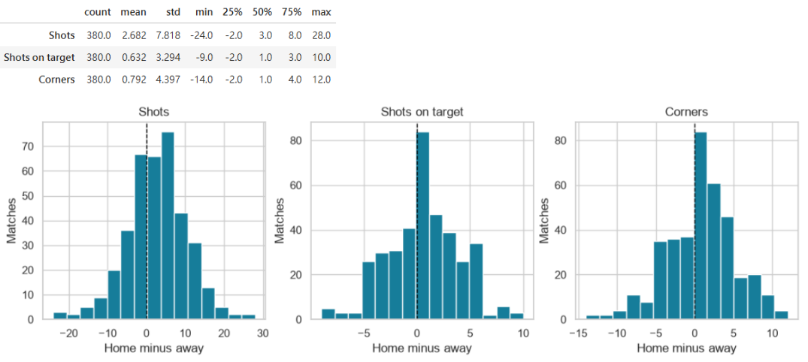
A statistics table and three histograms showing the distribution for three attacking stats across all the matches. All three histograms are right-skewed. On average, home teams perform more than away opponents, though away teams can still outperform the home side in individual games.

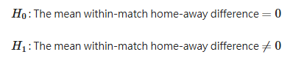
Paired t-test for home-away attacking differences. All tests are statistically significant, confirming home advantage with small effect sizes.
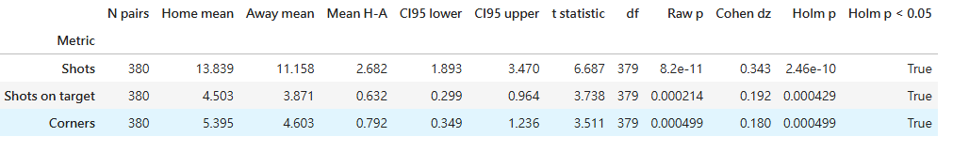

- Player Level Exploration (Notebook Section 6)
Generate a scatter plot of total goals and goals-per-90 versus player age, coloured by playing position (DF / MF / FW). The result shows scoring output differs greatly by position; forwards produce the highest scoring rates. No visible linear trend between player age and scoring output.
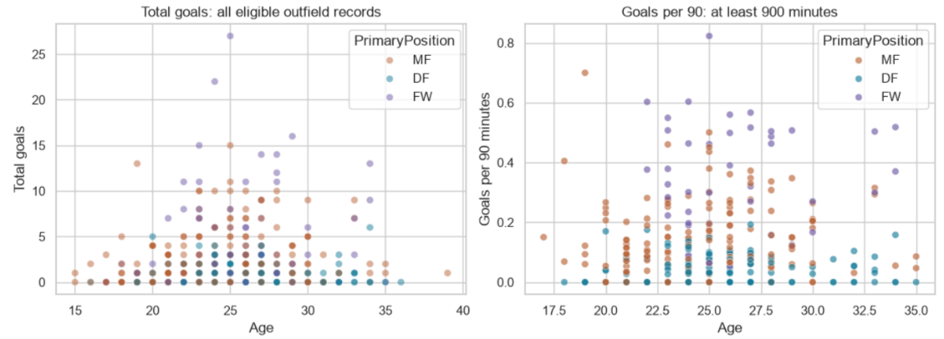

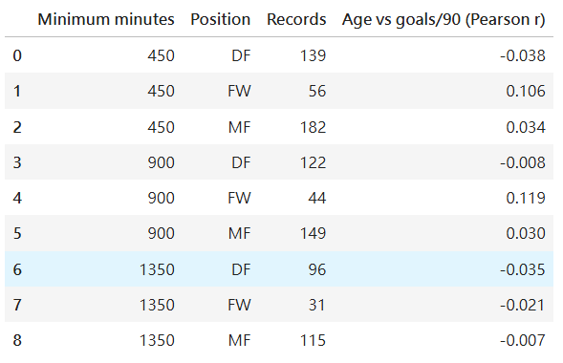
Compute a Pearson correlation sensitivity test below for age versus goals per 90 minutes at different playing-time thresholds. Near zero r values demonstrate no strong linear relationship between player age and scoring rate for defenders, midfielders or forwards.

- Project Criteria for Success
The project will be considered successful if the analysis is reproducible, the methods are clearly documented, and the findings address the research questions. Getting statistically significant results is not a requirement for success.
- The final Jupyter notebook can run fully from a fresh kernel, using only the two initial CSV source files as data inputs. Data validation checks are included.
- All data processing decisions are explained in the notebook, including how missing values are handled, how team names are matched between the two datasets, and how the numerical mismatches are identified.
- Generated tables show sample sizes alongside the denominators. All visualisations include meaningful titles, clear axis labels and appropriate units. Each figure and table is also paired with a short interpretation to explain the main patterns.
- Statistical outputs such as correlation coefficients and t-test results are reported together with effect sizes and confidence intervals. Since the same teams appear in multiple fixtures, this dependency issue is acknowledged, and Holm correction is applied when running multiple tests.
- All interpretations strictly distinguish statistical association from causation. No unsupported causal claims or predictions of future performance are made.
- The analysis addresses the primary research question and both supporting questions defined in this proposal.

- Project Collaboration Issues
- Tang Chi In (MC660146): Responsible for the proposal structure, sourcing the datasets, home-away comparative analysis, paired-sample hypothesis testing, player-level exploratory analysis and sensitivity correlation checks.

- Chen Iat Hong (MC654102): Responsible for notebook structure, dataset loading, data cleaning, team-level aggregation, attack-defence correlation analysis and results conclusion.

Both members review each other's work and discuss the interpretations together before finalising the notebook. Any questions about the data are addressed by consulting the dataset documentation.

